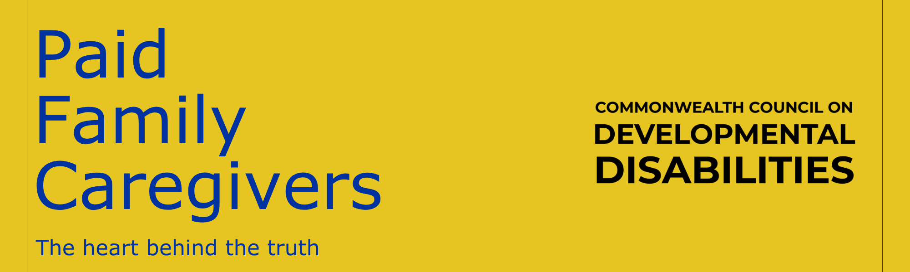

When people hear “paid family caregiver,” they often picture a parent getting paid to stay home with their child. What they don’t see is what happens behind closed doors.
They don’t see the medication schedules built around the clock.
The suction machines, feeding pumps, oxygen checks, therapy appointments, specialist calls, insurance battles, emergency plans, and sleepless nights.
They don’t see the charting, the training, the crisis management, or the constant state of hypervigilance.
What many people also don’t understand is that for a lot of families, this wasn’t a career choice. It was the loss of one. Many of us were forced out of the workforce because our loved ones needed care that no daycare, sitter, or traditional provider could safely give. We didn’t stop working; our work simply changed.
And without programs like this, many of our children, spouses, parents, or medically fragile loved ones would have no choice but institutional care or long-term care facilities. Not because their families don’t want to care for them, but because the system often gives families impossible choices.
A paid family caregiver isn’t “babysitting.” It isn’t “staying home.” It’s skilled, exhausting, deeply personal care given by someone who knows every baseline, every warning sign, every silent cue.
Some of us haven’t had an uninterrupted night of sleep in years. Some of us have learned medical skills we never imagined needing. All of us carry the weight of loving someone so deeply that walking away was never an option.
This role may come with a paycheck, but no amount of money could ever measure what it asks of a parent, spouse, or loved one. It doesn’t replace what was lost, but it helps families keep their loved ones where they belong: at home, surrounded by the people who know them best.
~Allison McElvain

